1 Applying Scale

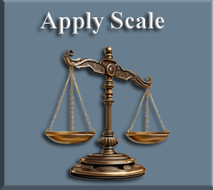

Warning, if you rescale the Reference Image or an object, and the scaling does not stick after saving. It is because the scaling needs to be applied first. Do not apply All Transforms, because it might do something weird like change the orientation of the image. For instance, mine ended up lying flat on the floor. Just apply the Scale.
CTRL -A: SCALE
